Ideation Phase

Brainstorm & Idea Prioritization Template

|  |  |
| --- | --- |
| Date | 5 October 2022 |
| Team ID | PNT2022TMID30482 |
| Project Name | AI Powered Nutrition Analyst for Fitness Enthusiasts. |

**Step-1: Team Gathering, Collaboration and Select the Problem Statement**

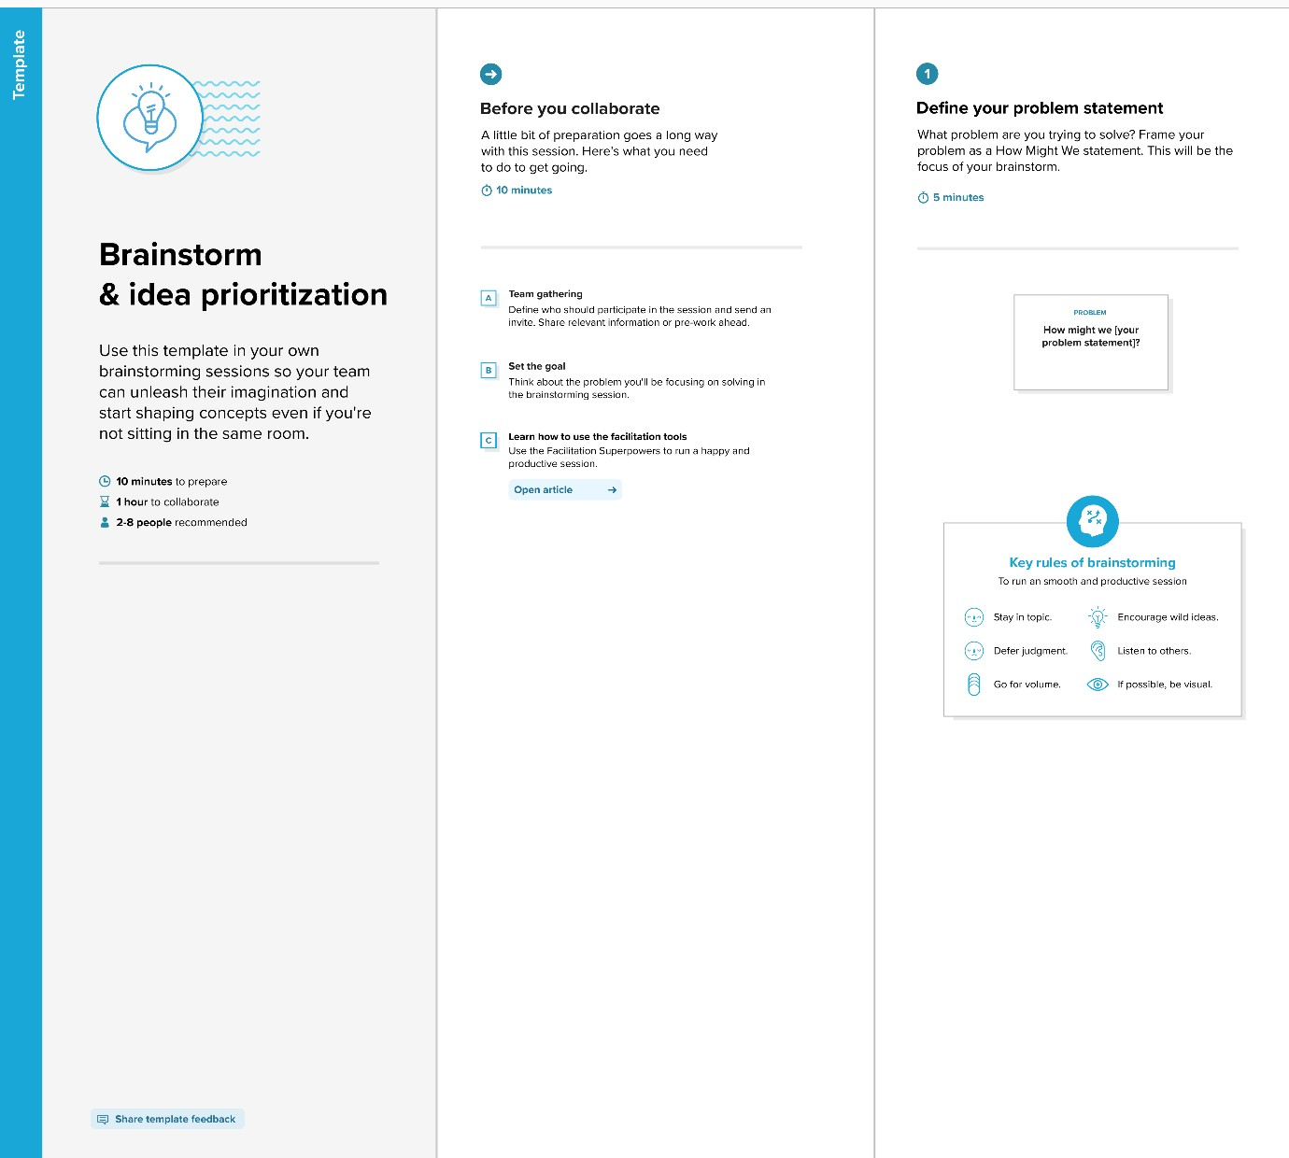

Step-2: Brainstorm, Idea Listing and Grouping

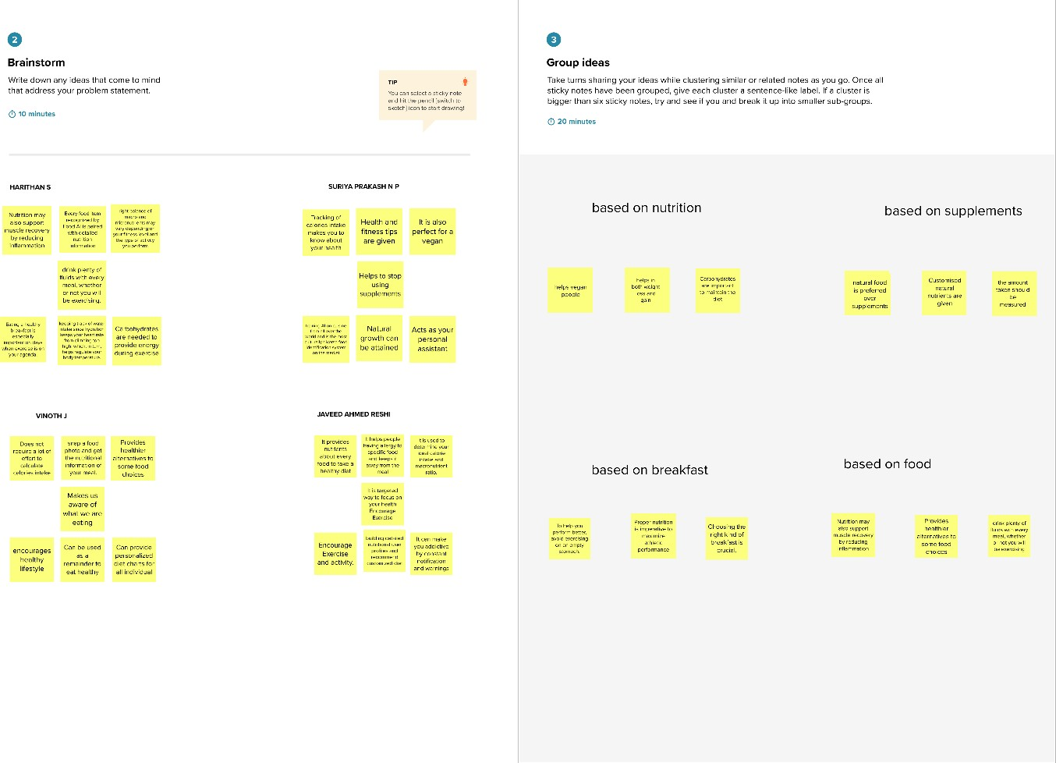

Step-3: Idea Prioritization

